BCT 2408 Lab 3
Enoch Teddy
SCT212-0078/2021
E1:
Solution
a. RAW: add requires the value of R1 returned by ld
b. WAW: add modifies the value of R1 that is also computed by mul
c. structural hazard for multiplier
d. RAW: sd requires (in MEM stage) the value of R1 computed by add
e. RAW: sd requires (in ALU stage) the value of R1 computed by add
E2:
Solution
- 2-bit saturating counter branch predictor
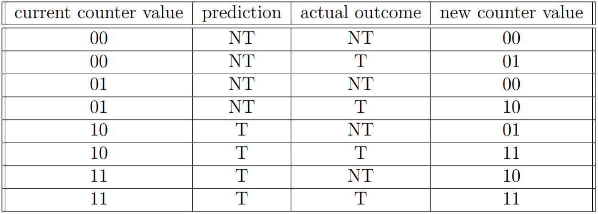
- 2-bit counter prediction rate
Iteration | Current Counter Value | Prediction | Actual Outcome | New Counter Value | Hit/Miss
1 | 00 | NT | NT | 00 | Hit
2 | 00 | NT | T | 01 | Miss
3 | 01 | NT | NT | 00 | Hit
4 | 00 | NT | T | 01 | Miss
5 | 01 | NT | NT | 00 | Hit
6 | 00 | NT | T | 01 | Miss
7 | 01 | NT | NT | 00 | Hit
8 | 00 | NT | T | 01 | Miss

